ARE RIGHT, A LOT
Definition and Indicators
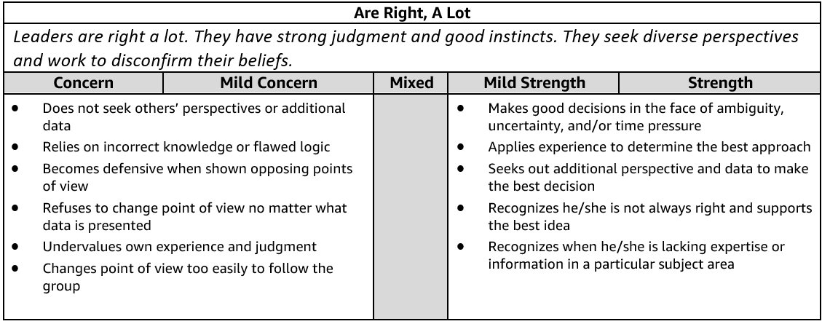
Are Right, A Lot - Suggested Behavioral Interview Questions
Please choose 2-3 questions below for your interview.
- Tell me about a time when you didn't have enough data to make the right decision. What did you do? What path did you take? Did the decision turn out to be the correct one?- DONE
- Tell me about a strategic decision you had to make without clear data or benchmarks. How did you make your final decision? What alternatives did you consider? What were the tradeoffs of each? How did you mitigate risk? DONE
- Tell me about a time when you made a difficult decision with input from many different sources (customers, stakeholders, partner teams, etc.). What was the situation and how did you arrive at your decision? Did the decision turn out to be the correct one? Why or why not?
- We don't always make the right decision all the time. Tell me about a time when you made a bad decision. What was the impact of that decision? What did you learn? How have you applied what you learned?
- We don't always make the right judgment all the time. Tell me about a time when you made an error in judgment. What was the impact? What did you learn? How have you applied what you learned?
- Tell me about a time when you discovered that your idea was not the best course of action. What was your idea? Why wasn't your idea the best course of action? How did you find out it was not the correct path? What was the best course of action? Who provided it? What did you learn from the experience?
- Describe a time when you brought different perspectives together to solve a problem. What types of different perspectives were represented? How did you seek out different points of view? What was the outcome? Where there any key learnings from this experience? Knowing what you know now, would you have done anything different?

Sample Answer:
I was working on an internal project for my previous employer that required me to work closely with
another member of staff from a different department. We had been working very well together for the
duration of the project, and we both had different skillsets and qualities that helped the project move
forward nicely. However, towards the end of the project, I received a call from my work colleagues
manager saying that she had been taken ill, and that I would need to finish the project on my own. The
only way for me to complete the project would be to use the limited information I had available, which my colleague had previously passed on to me before she went off sick. In the evenings, after work, I carried out lots of research to find out how to complete the elements of the project my work colleague had been responsible for. I ended up taking an online course, and I also went online to a couple of technical chat forums to ask for advice and information for the elements of the project I was struggling with. I am pleased to say that, after many nights additional work, and also by using the limited information my colleague had given to me, I was able to put the remaining pieces of the jigsaw puzzle in place and complete the project on time and to the correct standards.

Situation:
When I was working at WorldCourier, a project was underway to rearchitect the Customer Portal application to open up the application for global users spread across the globe with rich customer experience. Earlier this application was only inhouse and used by call center to take orders over the phone.
The Customer Portal application was old legacy application and built only for inhouse use and was not for scalability and lacked lot of customer experience features. There was no way to capture the usage patterns and key statistics for no of users and preference and predict behavioral patterns and had to assume there would be irregular peaks in traffic and had to be designed to be cost efficient.
We did many unknowns about storage capacity, scaling, and user count traffic etc
Tasks:
Create a new portal application for the above on tight timelines, with a fixed budget seasonal peaks for usage.
Actions:
- There were many different departments involved in the program with multiple stakeholders
- Worked with the different stakeholders including VP of sales, marketing, Product management, Project Sponsor and Enterprise architects, Application architects, UI/UX lead to design a solution.
- The need was for a scalable solution and we did not have enough information and statistics and usage patterns. I help discussions with the enterprise architecture, application architecture product owner and dev lead to deduce assumptions we can use capacity and user counts and decision was made to host this on the cloud for the elasticity and auto scaling and geo locations
- I ensured the design had enough parameters in the config and properties files to any possible discovery items that can be configured.
Results:
Happy ending.!! Hero wins and Villain dies…
- Keyword you want to use Assumptions, Unknown requirements are risks, Mitigation risk but the best available option or solution (Cloud)

• Situation
o Managing Program for American Airlines TechOps
o Colleague had personal issues and was quitting her job
o She gave her 2 weeks notice
• Tasks
Did not have enough time to transition and do knowledge sharing
o Several Key Projects were in progress and had tight deadlines
o Even in the 2 weeks notice she had to attend to family and we respected her stance
• Actions
o Took assessment of current situation
o Met separately with all Program Stakeholders
• Results
Answer:

BIAS FOR ACTION
Definition and Indicators
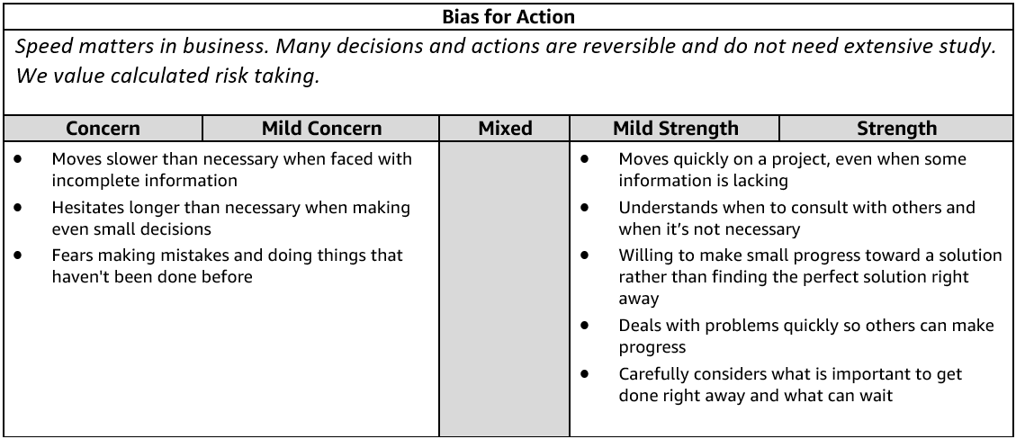
Bias for Action - Suggested Behavioral Interview Questions
Please choose 2-3 questions below for your interview.

- Give me an example of a calculated risk that you have taken where speed was critical. What was the situation and how did you handle it? What steps did you take to mitigate the risk? What was the outcome? Knowing what you know now, would you have done anything differently?
- Tell me about a time when you worked against tight deadlines and didn't have time to consider all options before making a decision. How much time did you have? What approach did you take? What did you learn from the situation?
- Describe a situation where you made an important business decision without consulting your manager. What was the situation and how did it turn out? Would you have done anything differently?
- Tell me about a time when you had to gather information and respond immediately to a situation. What was the outcome? Would you have done anything differently?
- Give me an example of when you had to make an important decision and had to decide between moving forward or gathering more information. What did you do? What was the outcome? What information is necessary for you to have before acting?
- Tell me about a time when you saw an issue that would impact your team and took a proactive approach to solve it. What was the issue? What did you do and what was the outcome? What did you learn from this situation?
- Tell me about a time when you felt your team was not moving to action quickly enough. What was the situation? What did you do? What was the outcome? Would you have done anything differently? (Manager)
- Tell me about a time when you were able to remove a serious roadblock/barrier preventing your team from making progress. What was the barrier? How were you able to remove it? What was the outcome? Knowing what you know now, would you have done anything differently? (Manager)

Sample Answer:
In a previous job, I had not been there that long when I was offered a promotion. This came entirely out
of the blue, and whilst I am very ambitious and enthusiastic, I decided to turn it down. The reason for me turning down the opportunity was based on the fact I genuinely wanted to learn my new role to a high standard, so I could then help the organization and my team develop. Although I feel I could have
performed well within the promotion, I did not want to risk my reputation and the performance of the
company, especially as I had only been there for a relatively short period of time. This was obviously a
risk on my part, as I may not have been offered the opportunity for promotion again. However, it proved
to be the right decision as my manager respected my choice, and I actually went on to be one of the
companies highest achievers.
- Upgrade to Oracle OEM 12 to 13. Basic features only work new features were not available.
- With client, what was the risk, impact was minimal and we went with older version monitoring tool were not supported latest features of new version.

Q1. Tell me about a time when you had to make a quick decision that was going to have significant impact on the organization?
Answer: I was managing a project for a very important client with a small group of people from different departments across the organization. We literally only had 10 days left before the project had to be completed, when the client contacted me with an urgent project specification change request. The
changes they were asking for would have a significant impact on the team’s ability to complete the project on time, and it would also eat into our project budget. I had very little time to make a decision, and so I decided to agree to the changes, primarily because
two of our core values were flexibility and customer focus.
The client had been with us for a long time, and I saw their business as valuable for the future health of the organization. Although we ended up making very little money from that project due to the unexpected specification change request, the client was very happy with the results and they went on to spend significant amounts of money with us in the future due to the strong relationship we had built up with them.
Verizon Wireless:
Situation: Our key competitor was not offering this feature. Business wanted the new feature implemented in release next month.
We absolutely had no capacity.
Tasks: Do every bit possible since primarily because two of our core values were flexibility and customer focus.
Action: Worked with business on swapping items.
I drove the CAB process with an exception
* Less resistance from Engg team, Swapped the must have to good to have features and with a little adjustment to resources
resource manager one QA resource available.
Results: Early to the market and significant economic benefit to the customer 20% increase in adoption to the product. Or Increase in market share

CUSTOMER OBSESSION
Definition and Indicators
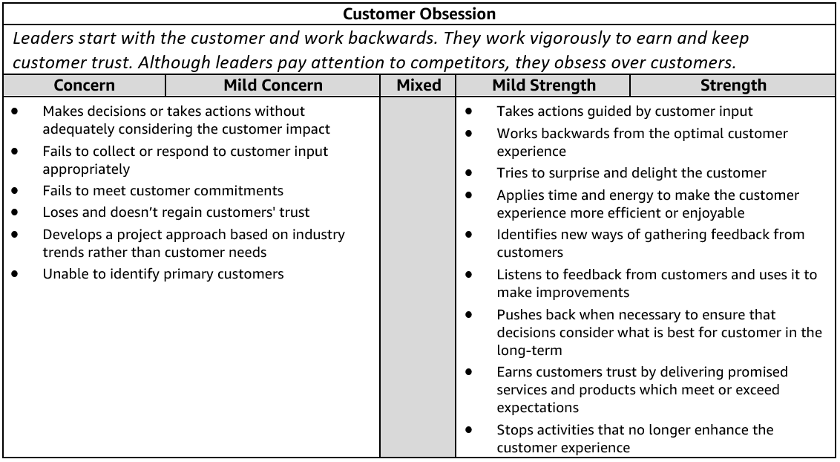
Customer Obsession - Suggested Behavioral Interview Questions
Please choose 2-3 questions below for your interview.

- Describe a difficult interaction you had with a customer. How did you deal with it? What was the outcome? How would you handle it differently?
- Tell me about a time when you went above and beyond for a customer. Why did you do it? How did the customer respond? What was the outcome?
- Give me an example of when you were able to anticipate a customer need with a solution/product they didn't know they needed/wanted yet. How did you know they needed this? How did they respond?
- Give me an example of a time when you asked for customer feedback. How did you use that feedback to drive innovation or improvement? How did the customer respond?
- Tell me about a time when you evaluated the customer experience of your product or service. What did you do? What was the result?
- Tell me about a time when a customer came to you for something that wouldn't actually address their need. How did you approach the situation? What was the result?
- Sometimes customers make unreasonable requests. Tell me about a time when you've had to push back or say no to a customer request. What did you say or do in response to that request?
- Tell me about a time when you had to balance the needs of the customer with the needs of the business. What did you do? What was the result?
- Give me an example of a change you implemented in your current team or organization to meet the needs of your customers. What has been the result? (Manager)

Digital Transformation:
- Situation: I have been working on digital transformation programs for a few years now.
- The one I would mention was when working in the Customer Technologies division of American Airlines for a project that aimed at Improving Customer Experience of passengers using the Self service machines during check in.
- Lot of investment was made on the self service machines but passengers were not using the machine, may not it was not a good experience and preferred to see a live agent agent and obtain their boarding pass.
- American Airlines had invested huge on the self service machines to avoid long lines at agent assisted check- in and avoid delays in passengers getting to the departure gate.
- Task:
- The vision of the project was to identify reasons why passengers did not want to use the kiosks
- Try and improve the customer experience on the kiosks so that more and more passengers can use the self service machines instead of going thru a live agent assisted check-in.
- Action:
- I scheduled meetings to brainstorm and analyze the problem.
- Review the screen flow to optimize and eliminate the additional clicks
- Based on which we captured behavioral patterns of customers for predictive analytics and built features on the self service machines application that offered easy check in, shorter duration to check-in at self service machines and also added custom personalization for each passenger based on his/her usage pattern.
- Results:
  - We measured and compared our success by comparing the average check-in time on self service machines before/after implementing the code changes.
  - Results showed considerable improvements in passengers using the SSM. On an average passengers were now taking 40% lesser time by using the kiosk and did not have to stand in the long lines.
  - Added to this the personalization feature was a huge success. The market research team and business team commended the efforts and received special appreciation and mention in our corporate monthly bulletin. The business leadership were impressed because we were ahead of our competitors on implementing the personalization feature.

Q7. Give me two examples of when you have gone above of beyond what was expected?
Sample Answer:
OPTION 1
SITUATION: I can remember a number of occasions when I would go above and beyond for a customer.
One particular time comes to mind when I was speaking to a customer on the telephone about a product they had recently ordered from our website. The product had, unfortunately, become damaged by the courier company, and they needed to return it for a replacement. However, there was an additional issue in the fact the customer really needed to use the product the next day, yet they were unable to, due to the damage that had been caused.
TASK: I put myself in the shoes of the customer and I could genuinely feel her frustration. I decided to take ownership of the situation and resolve the problem as it genuinely was not her fault the issue had occurred.
ACTION: I kept the customer on the line whilst I sourced a new ‘guaranteed delivery’ courier company
who was able to pick up and deliver a new replacement product within 24 hours. After some quick searching, I managed to find a company, and whilst the customer was still on the line, I facilitated the order. I then informed the customer that we would have a new product with her in time for the following
day, which she was absolutely thrilled about.
RESULT: The following morning I called the customer back to make sure the product had actually arrived in time, which it had done. The customer then went on to leave a glowing review of our company and I am pleased to say she has been a regular customer ever since. Sample Answer:
SITUATION: I don’t like to fail, but if I do, I always take ownership, put things right, and above all, view it
as an opportunity to learn, grow and develop.
During a challenging and exciting project at work in a previous role, I was part of a team of talented
people who were working on the creation of a new product for an important client.
TASK: The task required us to work together as a team and use our combined expertise and experience
to create the product for the client within very strict timescales and specifications. The project should
have been a breeze, simply because we had done this type of work together many times before.
Q7. Give me two examples of when you have gone above of beyond what was expected?
Sample Answer:
OPTION 2
SITUATION – In my previous job, I was managing the telephone lines and responding to customer calls. One day, an elderly gentleman telephoned to place an order online and he was clearly having problems selecting the product he needed and also making the payment over the phone.
TASK – I saw it as my task to spend time patiently helping the gentleman choose the right products for
him and to also talk him through the payment process, reassuring him along the way.
ACTION – I started off my asking him a series of probing questions to ascertain which product he needed.
Once we had achieved that stage, I then explained in detail how we would use his payment details to
process the payment, and that his details were totally secure. I then took the payment details and his
address for delivery. I also upgraded him to our free express delivery service to provide further reassurance that he would receive his good quickly.
RESULT – Although the customer was initially confused and he struggled to find the product he needed, I
managed to talk him through everything successfully by being patient and methodical in my approach. The customer was very happy with the service and he has since used our company again to buy products.

DELIVER RESULTS
Definition and Indicators
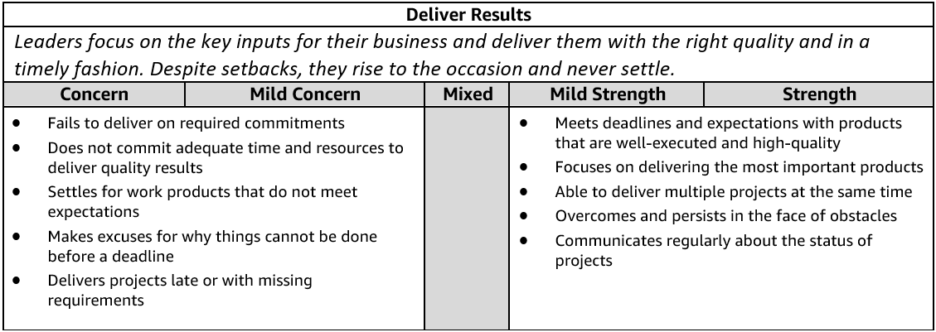
Deliver Results - Suggested Behavioral Interview Questions
Please choose 2-3 questions below for your interview.

- Give me an example of a time when you were able to deliver an important project under a tight deadline. What sacrifices did you have to make to meet the deadline? How did they impact the final deliverable? What was the final outcome?
- Tell me about a time when you had significant, unanticipated obstacles to overcome in achieving a key goal. What was the obstacle? Were you eventually successful? Knowing what you know now, is there anything you would have done differently?
- Tell me about a time when you not only met a goal but considerably exceeded expectations. How were you able to do it? What challenges did you have to overcome?
- Tell me about a time when you or your team were more than half way to meeting a goal when you realized it may not be the right goal or may have unintended consequences. What was the situation? What did you do? What was the outcome? Looking back, would you have done anything differently?
- Give me an example of a mission or goal you didn’t think was achievable. What was it and how did you help your team try to achieve it? Were you successful in the end? Looking back, would you have done anything differently?
- Tell me about a time when you did not effectively manage your projects and something did not get completed on time. What was the impact? What approaches do you use to make sure you are focusing on the right deliverables when you have several competing priorities?
- It can be difficult to set goals for a team that are challenging, yet achievable. Tell me about a time when you hit the right balance. How did you approach setting the goals? What was the outcome? (Manager)

DIVE DEEP
Definition and Indicators
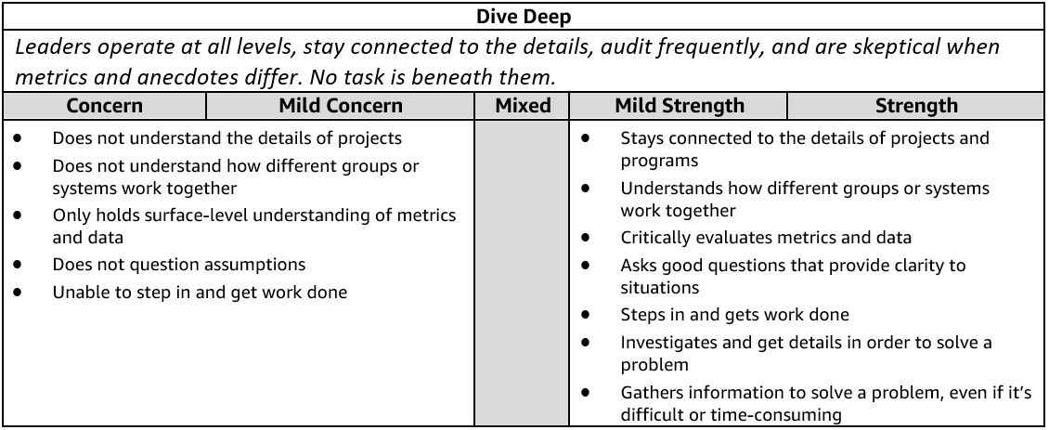
Dive Deep - Suggested Behavioral Interview Questions
Please choose 2-3 questions below for your interview.

- Tell me about a time when you were trying to understand a complex problem on your team and you had to dig into the details to figure it out. Who did you talk with or where did you have to look to find the most valuable information? How did you use that information to help solve the problem?
- Tell me about a situation that required you to dig deep to get to the root cause. How did you know you were focusing on the right things? What was the outcome? Would you have done anything differently?
- Tell me about a problem you had to solve that required in-depth thought and analysis. How did you know you were focusing on the right things? What was the outcome? Would you have done anything differently?
- Walk me through a big problem or issue in your organization that you helped to solve. How did you become aware of it? What information did you gather? What information was missing and how did you fill the gaps? Did you do a reflection at the conclusion of the project? If so, what did you learn?
- Tell me about a specific metric you have used to identify a need for a change in your department. Did you create the metric or was it already available? How did this and other information influence the change? What was the outcome of this change?
- Have you ever created a metric that helped identify a need for a change in your department? What was the metric? Why did you create it? How did this and other information influence change? What was the outcome of the change?
- Tell me about a time when you had to validate the assumptions underlying a direct report's project. How did you decide follow up was necessary? What steps, if any, did you take to validate the assumptions? What was the result? (Manager)

Situation:
* After a new release of our code we had an production issue with a major escalation in the field with AA doc verification system that runs on SSM. A passenger without a valid visa for the destination country was issued a boarding pass travelling to the destination country.
*AA had to pay huge amount of penalty to the regularity govt DOT department for such violations.
Tasks:
We had to fix the issue in the International doc verification module
* Research on the root cause analysis to determine what caused the issue.
Action:
* Worked with the team on the RCA for the problem. We did not have the session data captured in our database for our current Cognos reports.
* The team developed new reports using the log file data in Splunk to identify the root cause of this issue.
* The team researched the log file for specific keywords and confirmed that we had the needed information in the log files for the new new splunk report.
* Using the new splunk report we were able to identify the root cause where in the country code was missing in the configuration file. The older version of the config file was accidently deployed in production.
Results:
* We fixed the code for this issue. The PAX country of origin where not in our master table.
* We added a new set of automation test cases for regression testing for all countries and so prevented any further penalties and fines using this International Doc verification Automation regression test suite.

EARN TRUST
Definition and Indicators
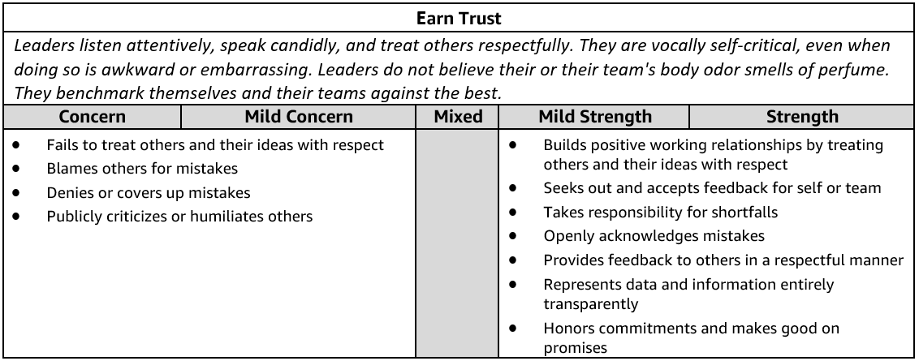
Earn Trust - Suggested Behavioral Interview Questions
Please choose 2-3 questions below for your interview.

- Tell me about a time when you had to communicate a change in direction that you anticipated people would have concerns with. What did you do to understand the concerns and mitigate them? Were there any changes you made along the way after hearing these concerns? How did you handle questions and/or resistance? Were you able to get people comfortable with the change?
- Give me an example of a tough or critical piece of feedback you received. What was it and what did you do about it?
- Describe a time when you needed to influence a peer who had a differing opinion about a shared goal. What did you do? What was the outcome?
- Give me an example of a time when you were not able to meet a commitment. What was the commitment and what were the obstacles that prevented success? What was the impact to your customers/peers and what did you learn from it?
- Tell me about a time when your team’s goals were out of alignment with another team you relied on in order to meet your goal. How did you work with the other team? Were you able to achieve your goals?
- Tell me about a time when you uncovered a significant problem in your team. What was it and how did you communicate it to your manager and other stakeholders? What did you do to address the problem? How did you manage the impact of this problem for the rest of your team?
- Describe a time when you improved morale and productivity on your team. What were the underlying problems and their causes? How did you prevent them from negatively impacting the team in the future?
- Tell me about a time when a team member was struggling to keep up or fit in and you stepped in to help out. Why did you think they were struggling or not fitting in? Why did you decide in step in and support? What did you do to help out? How did it impact your work? What was the outcome? What did you learn from that situation?
- Tell me about a time when a team member was not performing well and impacted your work. How did you handle that situation? Why were they not performing well? What was the outcome? What did you learn from that situation?

Answer: Moving from Manual testing to 100% Automation testing.

Actions: I created the business case for moving to 100% Testing
Worked with engineering and senior mgmt. to get approval for 100%.
I laid out the Strategy, Engage with key vendors, Determined the best fit for our use case scenario, Initiated the POC, Evaluated the results
Laid out the plan for operationalize the tool group wide and finally laid out the program plan
Results: Quality improved and adoption of the Automation test suite increased, and more and more teams liked our automation success stories and adopted the program. The automation tools we used were standardization across the organization

Example2: Agile adoption. Water fall to Agile.

HAVE BACKBONE; DISAGREE AND COMMIT
Definition and Indicators
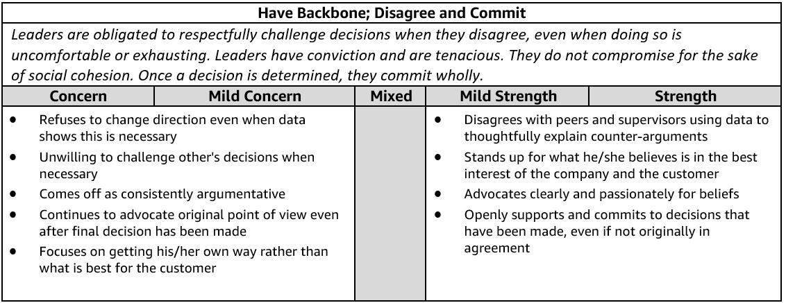
Have a Backbone; Disagree and Commit - Suggested Behavioral Interview Questions
Please choose 2-3 questions below for your interview.

- Tell me about a time when you strongly disagreed with your manager or peer on something you considered very important to the business. What was it and how did you handle it? Knowing what you know now, would you do anything differently?
- Describe a time when you took an unpopular stance in a meeting with peers and your leader. What was it? Why did you feel strongly about it? What did you do? What was the outcome?
- Often, we must make decisions as a group. Give me an example of a time you committed to a group decision even though you disagreed. What factors led you to commit to the decision? Would you make the same decision now?
- Describe a time when you felt really strongly about something on a project but the team decided to go in a different direction. How hard did you press the issue? How did you approach that project afterward?
- Tell me about a time when you pushed back against a decision that negatively impacted your team. What was the issue? How did it turn out? Would you have done anything differently?
- Give me an example of when you submitted a great idea to your manager and they did not support it. What was the idea? How did you handle the lack of support?
- Describe a time when you had to support a business initiative that you didn't agree with. How did you handle it? How did you deliver the message to your team?
- Tell me about a time when the business gained something because you persisted for a length of time. Why were you so determined? How did it turn out?

Q6. Tell me about a time when you experienced conflict within a team?
Sample Answer:
I was part of a project team in a previous role which included six other team members. We were tasked
with delivering an important web-based, time-sensitive project for an important client. During the initial
stage of the project we got together as a team to discuss and agree upon the initiation-phase of the
project, and also an agreed action plan. From the very first meeting, two members of the team took an
instant dislike to each other, and their constant disagreements were causing conflict within the team. I
took control of the situation and spoke up during the meeting to express my concerns that, unless we all
agreed to put our differences aside, and work collaboratively as part of a team to achieve the project
aims, we would all be responsible for the failure of the project. As soon as I raised the issue it was clear
the two team members knew they had to put their differences aside, which they agreed to do so. From
that point on, the conflict was stopped dead in its tracks and the remainder of the project went smoothly and according to plan.

Situation/Task: There was a disagreement on implementing a Futuristic approach using personalization or a quick win meet Acceptance Criteria approach.

Action: With the company goal in mind and Customer obsession approach, I discussed with the team and emphasized the need for implementing the additional (Personalization -Logo , WebEX), Customizing their branding monetization is based on personalization. Feature monetization
Lose their branding.

INSIST ON THE HIGHEST STANDARDS
Definition and Indicators
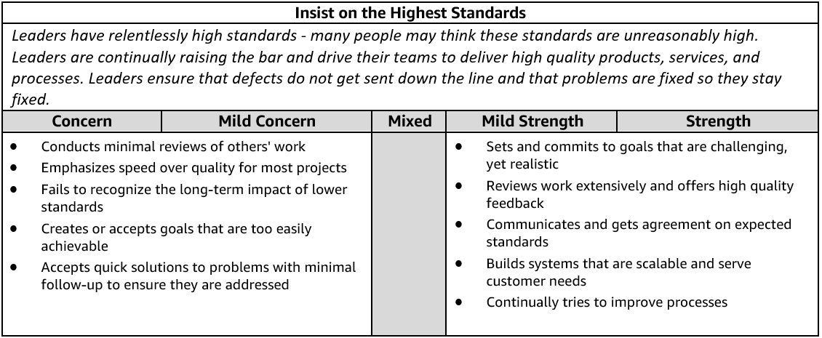
Insist on the Highest Standards - Suggested Behavioral Interview Questions
Please choose 2-3 questions below for your interview.

- Describe a time when you refused to compromise your standards around quality/customer service, etc. Who was your customer? What was the result?
- Tell me about a time when you were unsatisfied with the status quo. What did you do to change it? What was the impact? Would you do anything differently in the future?
- Tell me about a time when you worked to improve the quality of a product / service / solution that was already getting good customer feedback. Why did you think it needed improvement? How did customers react?
- Tell me about a time when you had to make a decision between standards and delivery. What tradeoffs did you have make? What was the outcome? Knowing what you know now, would you have done anything differently?
- Give me an example of a goal you’ve had where you wish you had done better. What was the goal? How could you have improved on it?
- Describe the most significant continuous improvement project that you led. What was the catalyst to this change and how did you go about it? What was the outcome?
- Tell me about a time when you used feedback about your team to drive a change. How did you gather or receive feedback on your team's performance? What was the outcome? (Manager)

INVENT AND SIMPLIFY
Definition and Indicators
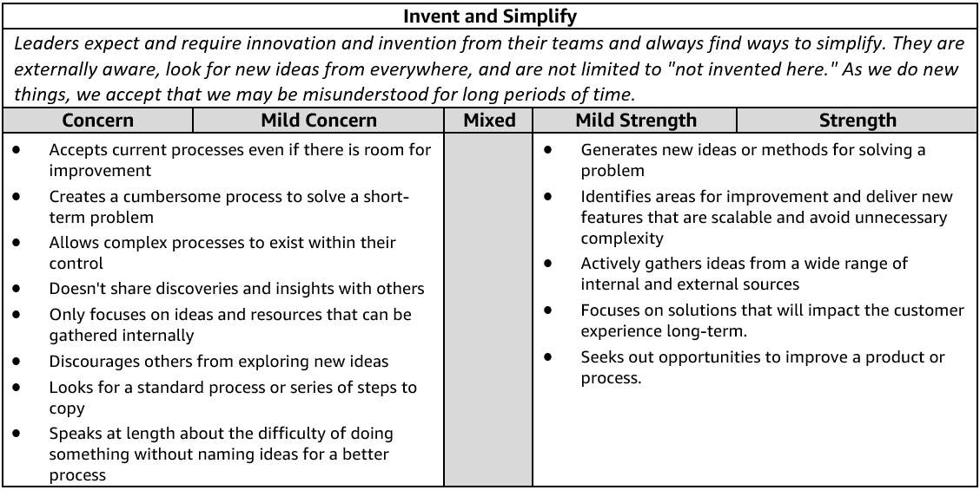
Invent and Simplify - Suggested Behavioral Interview Questions
Please choose 2-3 questions below for your interview.
- Give me an example of a complex problem you solved with a simple solution. What made the problem complex? How do you know your solution addressed the problem?
- Describe the most innovative thing you’ve done and why you thought it was innovative. Ask for one or two more examples to see if it's a pattern of innovative thinking. What was the problem it was solving? What was innovative about it?
- Tell me about a time when you were able to make something simpler for customers. What drove you to implement this change? What was the impact?
- Describe a time when you influenced and drove new thinking and innovation out of your team. Give an example of how your approach led to a specific innovation.
- Tell me about a time when you had a challenging problem or situation that the usual approach wouldn't address. How did you select an alternative approach? What alternative approach(es) did you consider? What was the end result? What was the impact?
- Tell me about a novel idea you had or decision you made that had a big impact on your business. What was novel about it?
- Tell me about a time when you enabled your team/a team member to implement a significant change or improvement. What problem were you trying to solve? How did you measure success? What was the end result/impact? (Manager)

Sample Answer:
I was in a meeting in my previous job where the company’s sales figures were being discussed by the
managers. Although the sales figures were healthy, there was concern amongst the group that the
profitability was not as good as it should be, due to the marketing spend that was ongoing. At the end of
the meeting, I decided to try and find a solution to this problem. I met up with the marketing team, and
they explained to me the bulk of the marketing spend was going on Facebook and social media adverts.
After some investigative work, it became apparent that the team were not using Facebooks tracking
pixels that are designed to measure the performance of the advertising spend. I quickly informed them of what I had found, and moving forward from that day on, the organization was able to measure accurately the marketing return on investment. This allowed us to cease adverts that were not giving us any return, which in turn increased profitability.
- M&A Team, Integration team, Standards team
- Standard tool sets.
or
- Situation: There was a complex scenario to be tested and we needed real-time production data for multiple dependent features.
  - Unable to reproduce in QA environment. Repeatedly several Production defects, bugs reaching the customer was BAD
  - (Facet design. Categories drop downs.)
- Task;
  - Resolve the repeated occurrence of issues as a very high visibility issue and on the radar of the client Executive Director
- Action:
  - I reviewed the issue and team, key business stakeholders including the UAT test lead.
  - I took a deep dive and tried several test runs with the team.
  - Identified the root cause of the issues was missing Realtime transaction data generated in the live production that is needed for testing the complex scenario Our QA and test environments did have this data.
  - I worked with the the client management to get approval for loading a snapshot of production data and as there were ISRM security constraints I had work with scrubbed personal data to be loaded in production
  - I was able to get the ISRM approval for scrubbing the PI data.
- Results: Resolved the issue…. And tell a happy story..!!!

Learn and Be Curious
Definition and Indicators
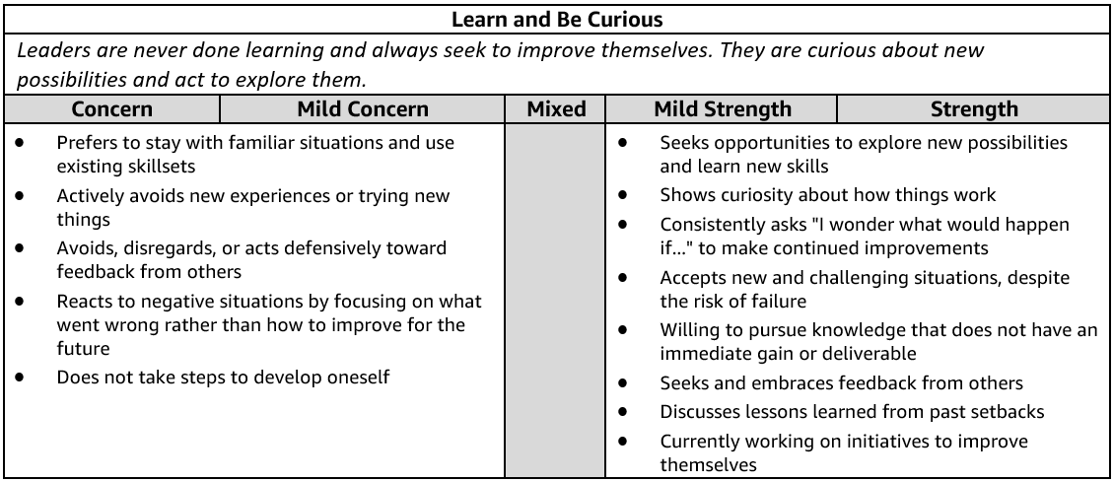
Learn and Be Curious - Suggested Behavioral Interview Questions
Please choose 2-3 questions below for your interview.
- Tell me about a time when you realized you needed a deeper level of subject matter expertise to do your job well. What did you do about it? What was the outcome? Is there anything you would have done differently?
- Describe a time when you took on work outside of your comfort area. How did you identify what you needed to learn to be successful? How did you go about building expertise to meet your goal? Did you meet your goal?
- Tell me about a time when you didn’t know what to do next or how to solve a challenging problem. How do you learn what you don't know? What were the options you considered? How did you decide the best path forward? What was the outcome?
- We all have things about ourselves we'd like to improve on at work. Give me an example of something that you've worked on to improve your overall work effectiveness. What resources did you identify to help you develop? What was the impact?
- Give me an example of a time when you explored a new or unexpected area of an existing space. Why hadn't this been explored already? Why did you move forward? What were the results or what was the impact?
- Describe a time when someone on your team challenged you to think differently about a problem. What was the situation? How did you respond? What was the outcome?
- Tell me about a time when you used external trends to improve your own company's products or services. How did you keep up to date with external trends? How did you decide to apply them to your own company? What was the result?

Answer:
Situation:
Evaluation of tools. Introduce the tools for adoption Tools are:
PM reporting: EZBI reporting, Tableau, Tosca for JIRA PM charts and reporting,
Automation: RPA tools (Blue prism, Automation anywhere, UI path)
Cloud: AWS Athena, Google cloud, AWS cloud services.
Action:
I laid out the Strategy, engage with key vendors, Determined the best fit for our use case scenario, Initiated the POC, Evaluated the results
Laid out the plan for operationalize the tool group wide and finally laid out the program plan
Results:
Widely accepted and standardization across the organization.

OWNERSHIP
Definition and Indicators
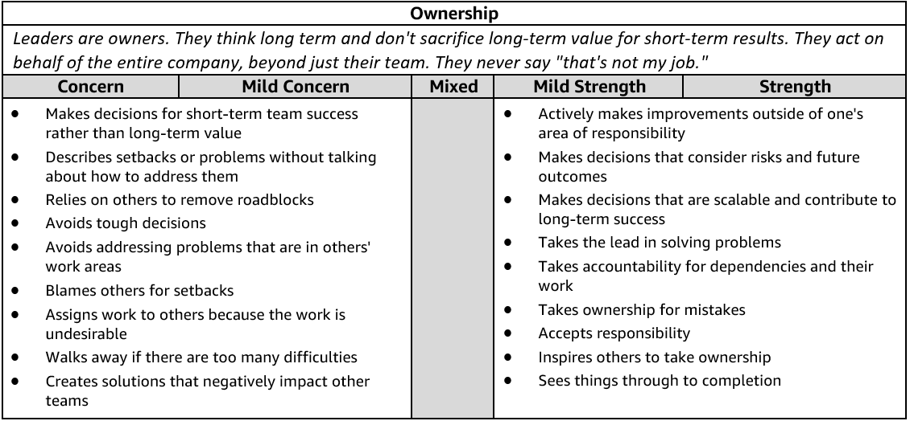
Ownership - Suggested Behavioral Interview Questions
Please choose 2-3 questions below for your interview.
- Tell me about a time when you took on something significant outside your area of responsibility. Why was it important? What was the outcome?
- Describe a time when you didn't think you were going to meet a commitment you promised. How did you identify the risk and communicate it to stakeholders? Is there anything you would do differently?
- Give me an example of an initiative you undertook because you saw that it could benefit the whole company or your customers, but wasn’t within any group’s individual responsibility so nothing was being done.
- Tell me about a time when you made a hard decision to sacrifice short term gain for something that would create long term value for the business. What was the outcome? Knowing what you know now, would you have done anything differently?
- Describe a time when you had to transition a project you owned to a new owner. What steps did you take to make sure the transition went smoothly? Tell me about a time that you chose to get involved in a project that you had already transitioned to somebody else. What was the situation? Why was it important to get involved?
- Tell me about a time when you saw a peer struggling and decided to step in and help. What was the situation? Why did you decide to step in? What actions did you take?

Situation:
  - Evaluation of tools. Introduce the tools for adoption Tools are:
  - PM reporting: EZBI reporting, Tableau, Tosca for JIRA PM charts and reporting,
  - Automation: RPA tools (Blue prism, Automation anywhere, UI path)
  - Cloud: AWS Athena, Google cloud, AWS cloud services.
- Action:
  - I laid out the Strategy, engage with key vendors, Determined the best fit for our use case scenario, Initiated the POC, Evaluated the results
  - Laid out the plan for operationalize the tool group wide and finally laid out the program plan
- Results:
  - Widely accepted and standardization across the organization.

THINK BIG
Definition and Indicators
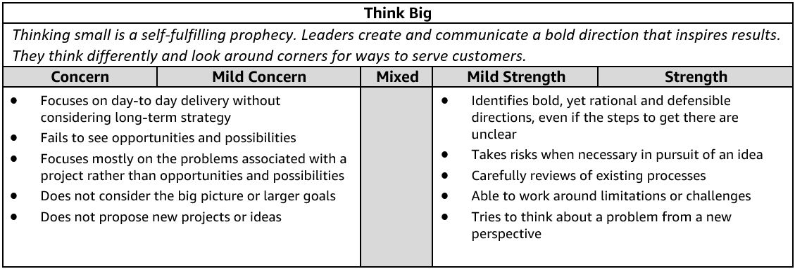
Think Big - Suggested Behavioral Interview Questions
Please choose 2-3 questions below for your interview.

- Tell me about time when you were working on an initiative or goal and saw an opportunity to do something much bigger or better than the initial focus. Did you take that opportunity? Why or why not? What was the outcome?
- Give me an example of how you have changed the direction or view of a specific function/department and helped them embrace a new way of thinking. Why was a change needed? What was the outcome?
- Give me an example of a time you proposed a novel approach to a problem. What was the problem and why did it require a novel approach? Was your approach successful?
- Tell me about a time when you drove adoption for your vision/ideas. How did you know your vision/idea was adopted by others? How did you drive adoption for your vision/ideas? How did you track adoption? Would you do anything differently?
- Give me an example of an idea or vision you had which was adopted by global stakeholders. How did you drive adoption for your vision/ideas? How did you track adoption? Would you do anything differently?
- Tell me about a time when you thought differently to improve a process that was working. What assumptions did you have to question? How did you evaluate if the change improved the process? Knowing what you know now, would you do anything differently?
- Tell me about a time when you encouraged a team member or organization to take a big risk. How did you balance the risk against existing business goals? What was the outcome? What did you learn from this situation? (Manager)
- Tell me about a time when you established a vision for a (team, product, initiative) when there wasn't one. How did you gain buy-in and drive execution? What was the outcome? Would you have done anything differently? (Manager)

Situation: I have been working on digital transformation programs for a few years now.
- The one I would mention was when working in the Customer Technologies division of American Airlines for a project that aimed at Improving Customer Experience of passengers using the Self service machines during check in.
- Lot of investment was made on the self service machines but passengers were not using the machine, may not it was not a good experience and preferred to see a live agent agent and obtain their boarding pass.
- American Airlines had invested huge on the self service machines to avoid long lines at agent assisted check- in and avoid delays in passengers getting to the departure gate.
- Task:
- The vision of the project was to identify reasons why passengers did not want to use the kiosks
- Try and improve the customer experience on the kiosks so that more and more passengers can use the self service machines instead of going thru a live agent assisted check-in.
- Action:
- I scheduled meetings to brainstorm and analyze the problem.
- Review the screen flow to optimize and eliminate the additional clicks
- Based on which we captured behavioral patterns of customers for predictive analytics and built features on the self service machines application that offered easy check in, shorter duration to check-in at self service machines and also added custom personalization for each passenger based on his/her usage pattern.
- Results:
  - We measured and compared our success by comparing the average check-in time on self service machines before/after implementing the code changes.
  - Results showed considerable improvements in passengers using the SSM. On an average passengers were now taking 40% lesser time by using the kiosk and did not have to stand in the long lines.
  - Added to this the personalization feature was a huge success. The market research team and business team commended the efforts and received special appreciation and mention in our corporate monthly bulletin. The business leadership were impressed because we were ahead of our competitors on implementing the personalization feature.
HIRE AND DEVELOP THE BEST
Definition and Indicators
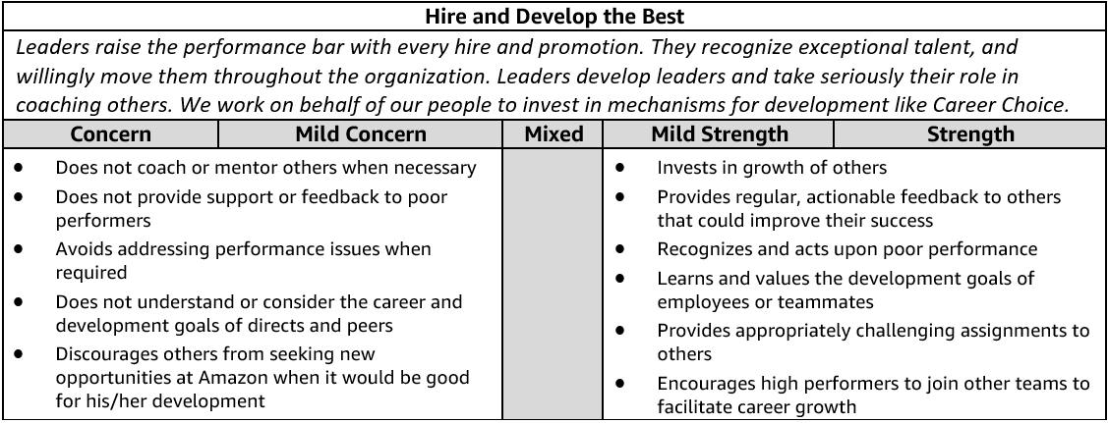
Hire and Develop the Best - Suggested Behavioral Interview Questions
Please choose 2-3 questions below for your interview.

- Tell me about a time when you helped one of your team members develop their career. How did you help that team member? What was the result?
- Tell me about a time when you invested in an employee's development. What did you invest in and why? What was the outcome? Can you share an example where investing in an employee's development didn't work out?
- Give me an example of a time you provided feedback to develop the strengths of someone on your team. Were you able to positively impact their performance?
- Tell me about a time when you provided coaching for a team member. What started the coaching? What was the outcome?
- Tell me about someone you hired that you thought complemented your skills. How did you coach an individual in areas where you have a weakness? (Manager)
- Tell me about a time when you helped a remote team member develop their career. Can you give me an example of a specific team member and how you helped them develop across the geographic distance? (Manager)
- Describe a person who struggled to get promoted under your leadership and how you helped facilitate their success. (Manager)
- Tell me about your most challenging talent review and promotion process that you conducted for your team. What made it challenging? What factors did you consider in your talent review? What factors did you consider in the promotion process? Did you incorporate a tool to counter unconscious bias? If yes, how? How do you manage perceptions of unfair treatment? What did you learn from this process? Knowing what you know now, would you have done anything different? (Manager)
- Describe a time when you constructed a team to accomplish a goal. What factors did you consider in constructing the team? Did you factor diversity into your team construction? How did you balance work requirements, team skill composition, and team stretch opportunities? What do you consider when you allocate work? How did you ensure team members were able to work effectively together? Would you have done anything differently? (Manager)
- Tell me about a time when you had a low performing individual on your team. How did you deliver feedback? Did their performance improve? (Manager)
FRUGALITY
Definition and Indicators
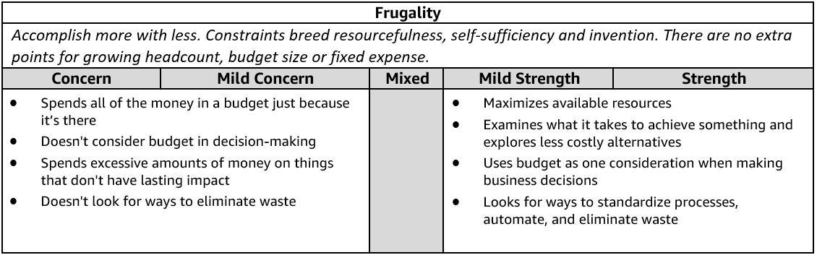
Frugality - Suggested Behavioral Interview Questions
Please choose 2-3 questions below for your interview.

- Give me an example of how you have helped save costs or eliminate waste within your role or organization. What was the situation? What was the impact?
- Describe a time when you had to get a project or initiative completed with limited resources. How did you approach the situation? What was the impact? Knowing what you know now, would you have done anything differently?
- Tell me about a time when you didn’t have enough resources to do something you felt was important but found a creative way to get it done anyway. What was the situation? What other options did you consider? How did you decide on a path forward? What was the outcome?
- Tell me about a time when you had to make tradeoffs between quality and cost. How did you weigh the options? What was the result? Would you have done anything differently?
- Tell me about a time when you generated a creative solution to a problem or project without requiring additional resources. What was the problem? What was the solution and how did you come up with it? What was the outcome?
- Give an example of a time you requested additional funding/budget to complete a project. Why was it needed? Did you try to figure out another approach? Did you get the additional resources? Why or why not?
- Describe a time when you had to decide whether or not to award or ask for additional resources. What criteria do you use for making the call? What was the outcome? Knowing what you know now, would you have done anything differently? (Manager)
- Give an example of a time when you challenged your team to come up with a more efficient solution or process. What drove the request? How did you help? What were some of your biggest challenges? What were the end results? (Manager)

Q5. Tell me how you would complete a project or task if you had limited time or resources?

I believe in the modern-world we need to make more effective use of outsourcers to complete specific
tasks, and that is what I would do if I had a difficult project to coordinate which had a tight budget and
limited resources. There are some excellent websites available such as Upwork.com, Freelancer.com
and also PeoplePerHour.com where I could access experts from different industries such as graphic
design, web development, ecommerce and admin, etc. I would use these experts to carry out specific
project tasks where I was unable to hire someone internally. This approach would have a number of
benefits in the fact that I would not need to manage the people directly, and they would also only get paid unless the project task was completed to my specification and also the required standards that I set. This smart approach to project coordination would ensure I could manage multiple-tasks remotely and also, more importantly, at a reduced cost. I would also put in the extra hours if time was limited. In the past, I have worked on projects with extremely tight timescales, and when this type of situation occurs, I will always work late into the night to make sure I meet the deadline.
Comp off, reusable Automation, scripts parameter
Recognition: MVP, star performer, Game or points, Customer Appreciation award CAA award.,
5k in quarter, Apart from Bonus. Dinner with your family
Fast tracking,
Things in parallel, (Rework may be needed)
Test your interface,
What is the critical path, what is offsite and offshore to continue to keep quality, East Europe Romania cutting edge user experience Soft vision, Endava
Automaton, dev ops life cycle, cost less

STAR WORKSHEET
Your Behavioral Question: __________________________________________________________________ Leadership Principle: ______________________________________

- Choose behavioral question that provoke specific examples or stories for your assigned Leadership Principle(s).
- Process the example using STAR. Stories have beginnings (Situation/Task), middle (Actions) and ends (Results).
- Once you have established the story, PROBE to dive deeper on your assigned competency (Leadership Principle), get clarity or pursue a concern.
- If appropriate, CHALLENGE the candidate’s statements, decisions or thought process.
S  T | SITUATION/TASK - Describe the situation/task you faced and the context of the story  Answers the questions: where did this occur, when did it happen, why is it important?  Probing Questions:  - Why is this important? What was the goal?  - What was the initial scope of the project? What were the challenges?  - What were the risks and potential consequences if nothing happened?  Challenge Questions:  - Why did you choose this story to illustrate a xyz accomplishment?  - What other stories can you think of that demonstrate…xyz?  - Could you come up with an example that is more recent? | Notes
A | ACTION - What actions did you take?  Answers the questions: what did you personally own, how did you do it, who else was involved?  Probing Questions:  - Deep probe functional expertise and/or assigned core competency.  - Were you the key driver or project owner?  - What was your biggest contribution? What unique value did you bring?  - What were the most significant obstacles you faced? How did you overcome them?  Challenge Questions:  - What did you do specifically versus the team?  - How did you set priorities…deal with xyz problem… or get manager buy-in?  - What decisions did you challenge? Why? How did you influence the right outcome?
R | RESULTS - How did you measure success for this project? What results did you achieve?  $ Cost savings, revenue generation  # Quantify to understand volume, size, scale  % Percentage change, year over year improvements  Time to market, implementation time, time savings  Impact on the customer, the team  δ Quality improvements  Probing Questions:  - Why did you choose to focus on these results? What other results were important?  - You mentioned revenue, what percentage change is that year over year?  - What trade-offs did you have to make to achieve this? (quality, cost, time)  - I’m concerned about…(the time it took, the volume, the customer impact), tell me more…  Challenge Questions:  - What were the lessons learned? What would you have done differently?  - How would you implement this at Amazon?  - How did these results compare to your actual goals? (refer back to goal stated in Situation)

